Assignment 2: Implement Constraint Satisfaction Problem (CSP)

Problem Statement:
The goal of this assignment is to solve a constraint satisfaction problem (CSP) like Sudoku using backtracking. You will learn to represent the problem, define its constraints, and implement an algorithm to find a valid solution.

Objectives:
- Learn to represent and solve CSPs.
- Implement backtracking to find solutions effectively.

Theory

What is a CSP?
A CSP consists of:
- Variables: Elements that need to be assigned values (e.g., cells in Sudoku).
- Domains: The set of possible values each variable can take (e.g., numbers 1-9 for Sudoku).
- Constraints: Rules that dictate how variables can be assigned values (e.g., no two cells in the same row, column, or sub-grid can have the same value in Sudoku).

Methodology
- Define Variables, Domains, and Constraints:
  - For a Sudoku puzzle, each cell is a variable.
  - The domain for each variable is the numbers 1 to 9.
  - Constraints ensure that no two variables in the same row, column, or 3x3 sub-grid can have the same value.
- Start with an Empty Assignment:
  - Initialize an empty grid for Sudoku where you will assign values to variables.
- Use Backtracking:
  - Assign a value to a variable and check if the assignment satisfies all constraints.
  - If it does, move to the next variable.
  - If it does not, backtrack and try a different value for the previous variable.
  - This process continues until a valid solution is found or all possibilities are exhausted.
- Continue Until a Valid Solution is Found:
  - If a valid configuration of the entire grid is reached, output the solution.
  - If no solution is possible, indicate that as well.

Working Principle / Algorithm
Here’s a basic outline of the backtracking algorithm to solve Sudoku:
- Find the Next Empty Cell:
  - Scan the grid for the next cell that needs a value.
- Try Each Possible Value:
  - For each number from 1 to 9:
    - Assign the number to the empty cell.
    - Check if the assignment is valid (i.e., it does not violate any Sudoku constraints).
    - If valid, recursively call the function to assign values to the next cell.
- Backtrack If Necessary:
  - If the recursive call leads to a solution, propagate that solution upwards.
  - If not, reset the cell and try the next number.
- End Condition:
  - If all cells are filled correctly, the puzzle is solved.

Advantages
- Structured Approach: CSPs provide a clear framework to structure problems using variables, domains, and constraints.
- Effective for Many Variables: The backtracking algorithm is particularly effective for problems with numerous variables and complex constraints.

Disadvantages / Limitations
- Performance: Backtracking can be computationally expensive and slow for large CSPs, particularly as the number of variables and constraints increases.
- Exponential Time Complexity: The worst-case time complexity can grow exponentially with the size of the problem.

Diagram

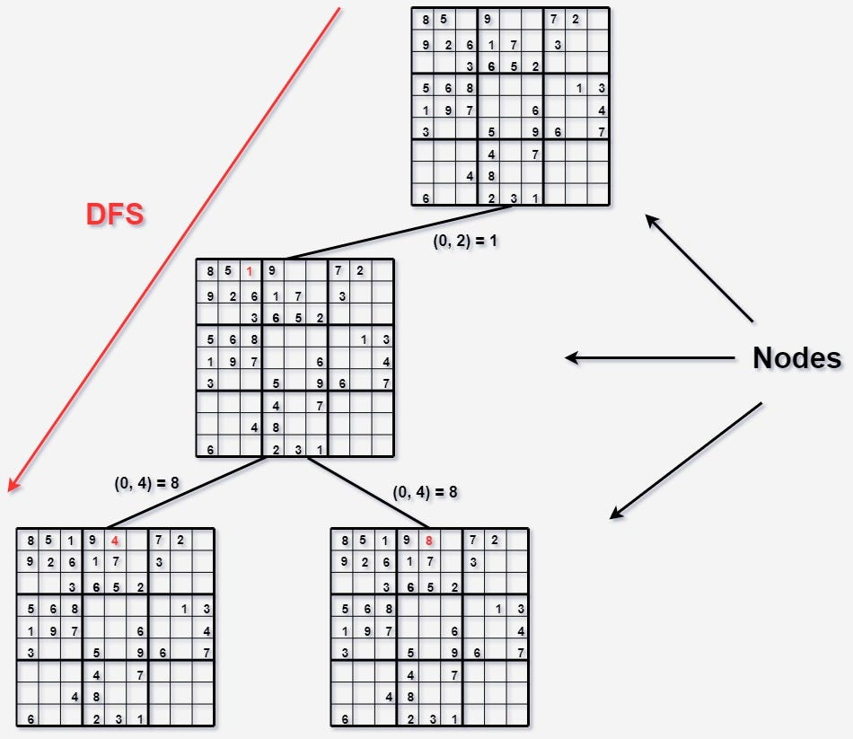

Conclusion
CSPs offer a systematic way to approach complex problems by framing them in terms of constraints. The backtracking technique allows us to explore possible assignments efficiently, making it a valuable tool for solving problems like Sudoku and many others.

